Lab Experiment 2

**DFD Model (Level 0, Level 1 DFD, and Data Dictionary) of Inventory Management System**

Name – Debangan Ghosh

Roll – AP22110010984

Class – CSE – Q

**DFD Model**

In Software Engineering, a Data Flow Diagram (DFD) represents a system at different levels of abstraction. It illustrates how data moves through an information system but does not include program logic or processing steps.

DFDs are structured into different levels: Level 0, Level 1, Level 2, etc. The choice of DFD level depends on system complexity and the level of detail needed. Higher levels provide a broad overview, while lower levels show detailed processes and data flows.

**Basic DFD Symbols**

1. **Process**: Transforms incoming data into outgoing data.
2. **Data Flow**: Represents data movement between entities, processes, and stores.
3. **Data Store**: A repository that holds system data.
4. **External Entity**: Objects outside the system that interact with it.

**Creating Data Flow Diagrams**

Creating DFDs is an iterative process of gradual refinement:

* **Create a Preliminary Context Diagram**: Defines system boundaries, external entities, and data flows.
* **Identify Use Cases**: Determines primary user interactions with the system.
* **Create DFD Fragments**: Develops smaller diagrams for individual use cases.
* **Combine into Level 0 DFD**: Shows the major processes and data flows.
* **Expand to Level 1 and Beyond**: Breaks down complex processes into detailed sub-processes.
* **Iterate and Validate**: Refines diagrams based on feedback.

**Level 0 DFD - Context Diagram**

**Purpose**

The **Level 0 DFD** provides a high-level view of the Inventory Management System, outlining interactions between external entities, processes, and data stores.

**Key Components**

* **Central Focus**: The Inventory Management System acts as the core process.
* **External Entities**:
  + **Admin**: Manages inventory, updates stock, and generates reports.
  + **Supplier**: Provides stock updates.
  + **Customer**: Places orders and checks product availability.
* **Data Stores**:
  + **Inventory Database**: Holds product details, stock levels, and reorder points.
  + **Order Database**: Stores customer orders and processing details.
* **Data Flows**:
  + Customers send **order requests**, and the system processes them.
  + Suppliers send **stock updates**, and the system updates inventory records.
  + Admins retrieve reports from the **Inventory and Order databases**.

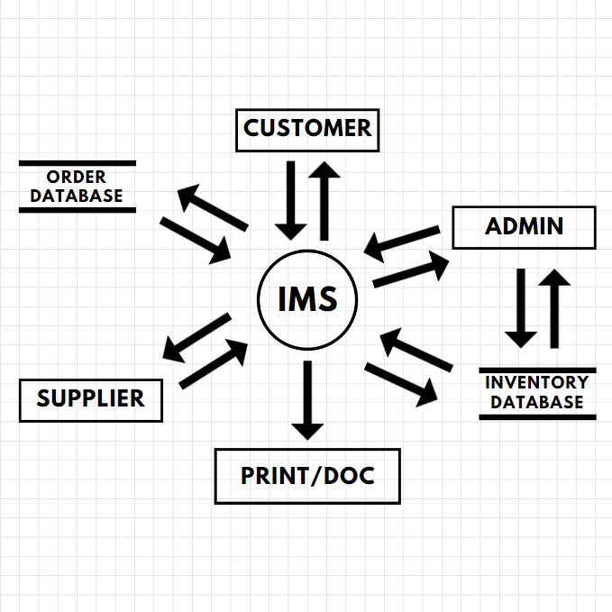

**Level 1 DFD - Detailed Process Breakdown**

**Purpose**

The **Level 1 DFD** expands on Level 0, breaking major processes into detailed subprocesses.

**Primary Processes**

1. **Manage Inventory (Process 1.0)**
   * **1.1** Add/Update Inventory
   * **1.2** Remove Outdated Stock
   * **1.3** Generate Low-Stock Alerts
2. **Order Processing (Process 2.0)**
   * **2.1** Receive Order Request
   * **2.2** Validate Order
   * **2.3** Update Inventory
   * **2.4** Confirm Order to Customer
3. **Report Generation (Process 3.0)**
   * **3.1** Retrieve Sales Data
   * **3.2** Generate Report
   * **3.3** Provide Report to Admin

**Data Dictionary**

**Definition**

A data dictionary provides metadata about the data elements used in the system, ensuring a clear and standardized understanding of data flows.

**Data Flows**

| **Name** | **Description** | **Source** | **Destination** |
| --- | --- | --- | --- |
| Order Request | Details of a customer order (items, quantity) | Customer | System |
| Stock Update | Updated stock levels from suppliers | Supplier | Inventory Database |
| Order Confirmation | Confirmation sent after processing | System | Customer |
| Low-Stock Alert | Notification for low inventory | System | Admin |
| Sales Report | Inventory and sales analytics | System | Admin |

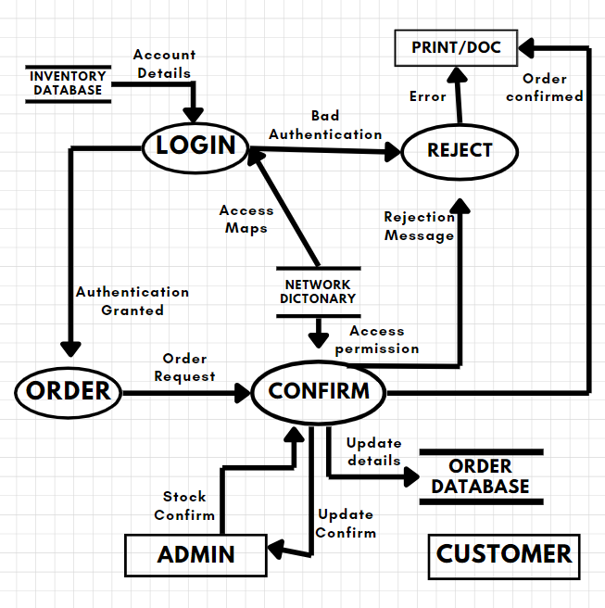

**Data Stores**

| **Name** | **Description** | **Attributes** |
| --- | --- | --- |
| Inventory Database | Stores product details, stock levels, and reorder thresholds | Product ID, Name, Quantity, Supplier |
| Order Database | Tracks customer orders, order status, and order history | Order ID, Customer ID, Status |

**Entities**

| **Name** | **Description** |
| --- | --- |
| Admin | Manages inventory, updates stock, and generates reports. |
| Supplier | Provides stock updates and restocks inventory. |
| Customer | Places orders and checks product availability. |

**Processes**

| **Name** | **Description** |
| --- | --- |
| Manage Inventory | Handles product updates, stock control, and alerts. |
| Process Orders | Validates and processes customer orders. |
| Generate Reports | Extracts sales data and inventory insights. |